Pratical name :- Update the table

Batch :- B5

Student name :- Utkarsh Divakar Patil

Roll no :- 151

INPUT:

use studentdb;

select \* from studentdb

update studentdb set name ='Pranav'where rollno=2

update studentdb set name ='Rahul'where rollno=5

update studentdb set name ='Pradip'where rollno=6

OUTPUT:

-

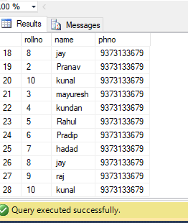

INPUT:

DELETE FROM studentdb WHERE rollno=9

OUTPUT:

